**Discussions On Research Paper**

1. About problem statements
2. Today in meeting sir asked us to search for types of batteries for robot, types of batteries used in mobile chargers, outside using algorithms for sanitization and how long does charging require for robots and mobile chargers.

**About problem statements**

1. Robo delivering food and tab in hospital.
2. Sanization.

Questions by professor:-

-how many robots are required for each room.

Sol:- each room will have one social robo and like 10 rooms if we take 5 robo will give priority to food delivery as their main task and other 5 robos will take care of sanitization. But all will participate in every job.like below.

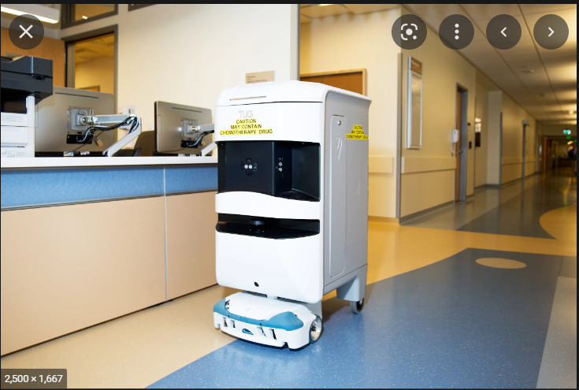

- Delivery challenges

Sol:- case1 in general-We are going to make a time bracket for each room for food delivery, giving priority to emergency wards.

Case 2:- if something urgent comes up in other room regarding cleaning:-

So our robo will give his food to social robo or the robo next to him can share the load for a fraction of time and this can attend his priority task as a disinfectant robo.

<https://www.wired.com/story/tug-the-busy-little-robot-nurse-will-see-you-now/>

Sample link for robo.

**Battery Issues for robos**

**Challenges:-**

* For food and sanitization robo battery issues

Sol:- <https://www.batterypowertips.com/battery-options-mobile-robots-faq/>

The two most common lithium chemistries in these applications are variations on lithium-ion (Li-ion), and lithium iron phosphate (LiFePO4). Li-ion and LiFePO4 offer designers performance tradeoffs that make them suitable for specific types of applications.

Li-ion has an energy density of 150 to 250 Wh/kg compared with LiFePO4, with an energy density of 90 to 120 Wh/kg. Li-ion and Li-polymer batteries have voltages from 3.6 to 3.85V, depending on the chemistry and design. LiFePO4 has a lower voltage of 3.2V, which contributes to the lower energy density of these batteries.

* Charging indication to robots at what percent, fast charging batteries

Sol:- 1. <https://www.gwsrobotics.com/robots-health-care-hospitals>

Pepper is the first robot in the world to be used to greet people in a medical setting. 12 hours’ activity per charge, a robot can be active for a full working day.

Pioneered at the AZ Damian hospital in Ostend (Belgium),

2.For charging they will go to battery station and change battery packs.

* Sanitization algorithms

Sol:- <https://www.medtronic.com/content/dam/medtronic-wide/public/brand-corporate-assets/resources/5-ways-artificial-intelligence-transforming-healthcare.pdf>

The **Pause algorithm** reduced LINQ II™

ICM false pause alerts by 97.4% and

preserved 100% of true pause alerts.2

By differentiating between false and true

alerts, this AI algorithm can help clinicians

focus on the right patients at the right time

in the right way